Display_Name..
Computer Programming Using Kivy - OpenGL 7 - Using Variables in 3D Scene
GOAL: Apply variables to 3D characters and create a conditional event when changes.

(You must first have a completed and working opengl6.py)
Update the 3D engine:
- Go to your home drive (File Explorer, Computer, T:\username or H:)
- Go to your opengl folder, then double-click update-kivyglops

Load the HUD image in your program:
- Open Geany
- File, Open, your home drive (such as T:\username or H:), opengl, opengl6.py
- File, Save As, go to your opengl folder, then name this file opengl7attack.py
- In the load_glops method after the code that loads the spaceship, setup characters with hit points and give them weapons. A dictionary can be declared with “dict()” or “{}”:

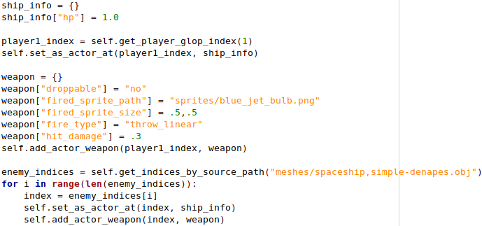

- In MainForm, handle the attacked_glop method and cause the character to explode if hp is 0 or lower:

